
Auxiliary Aids
Policy date: 10/9/2026

Review date: 10/9/2027

Lead personnel: J. Davison

Review frequency: Annually

Approval by: C.Midgley

Date approved: 15/9/2026

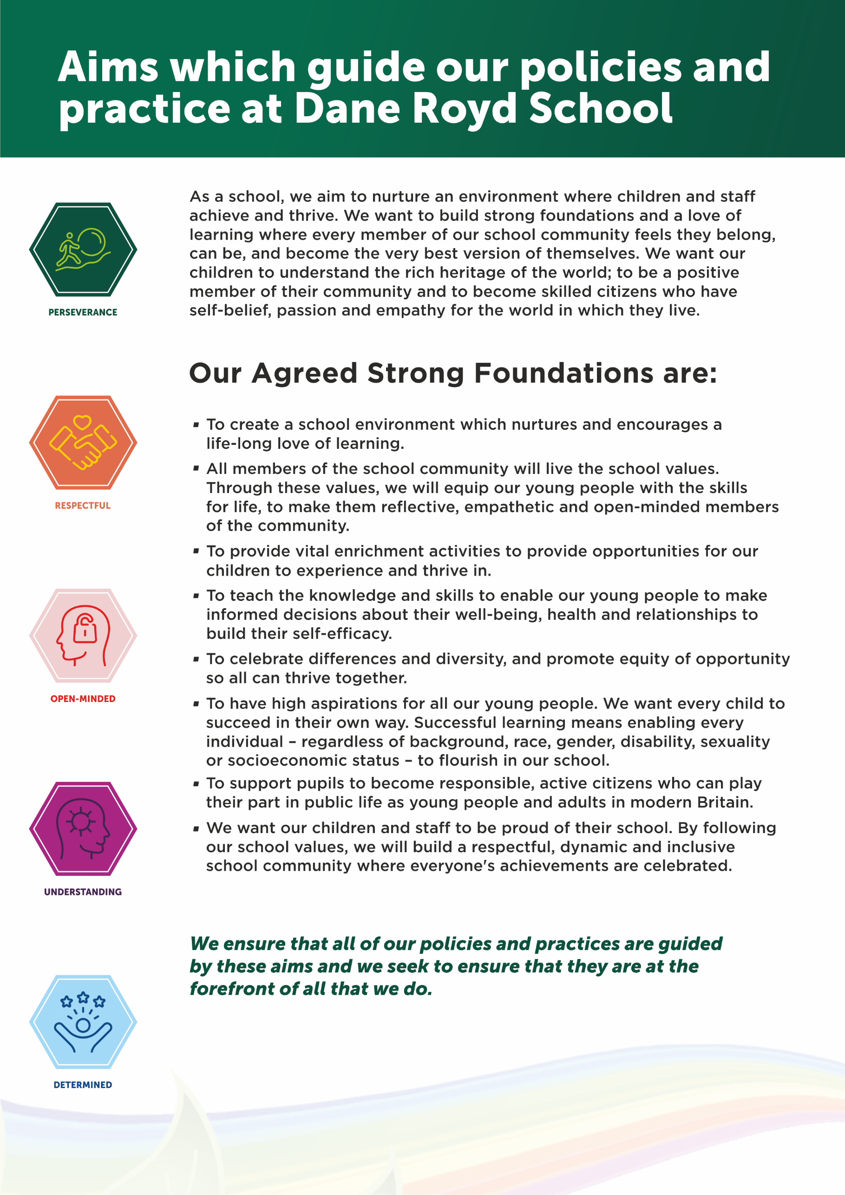

Auxiliary Aids and Equipment
The Equality Act 2010 says that both school and academies and the Local Authority have a duty to provide auxiliary aids and equipment. Auxiliary aids could be a teaching assistant or it could be equipment that helps a child or young person at school. This is only for equipment to be used in a child or young person’s school or academy or which needs to be provided to make education accessible.
In Wakefield, schools and academies use their own money to buy equipment for children and young people when the equipment costs less than £1000. If it costs more than £1000 then the person who thinks a child or young person needs the equipment puts a request into the Local Authority. This person could be a physiotherapist or an occupational therapist, it could be a specialist teacher such as a teacher of the deaf. A child or young person does not need to have a statement or a new Education Health Care Plan to have equipment bought by the Local Authority.
If the school or academy buys the equipment, it belongs to the school or academy. When a child or young person moves to a different school or academy or goes to college, it is up to the new school or academy or college to make sure they get the right equipment.
If the Local Authority buys the equipment, the equipment will go with the child or young person whilst they are in education.
Sometimes a child needs a system of equipment like an FM system if they are deaf or a
specialist seating/wheelchair system. This is looked at as the same need a single piece of equipment and when it costs more than £1000, the Local Authority would buy the equipment on behalf of the child or young person.

