Magical Mapping! - KS1 Hªo°e[ŸoŒ„ Aªc[t[i[vi[t[¬e¡

P¶i]c[„ ªa[n]d ªc[h]šoÇe ¶™h[ich ªa]c[t[i[vi[t[¬e¡ ¶Ó‹u ¶Ÿou[ld ¶l[i[…e ¶t]‹ ªc]om[p[¯e[·e ¶t[h[i¡ ¶h]a[ló ¶·e[rm, colour the smiley face to show which you completed.
Ió ¶Ó‹u ¶Ÿou[l]d ¶l[i[„e ¶t]‹ ¡[h]are ¶Óou[r ¶h]o°e[ŸoŒ„ p[¯e]a¡e ¶b[ri[n]ü ¶i[t ¶i[n[t]‹ ¡]c[h]šŠl ¶b[þ Thursday 25th May or alternatively email it to
homework daneroyd.com (let the teacher know!)

Weekly tasks | 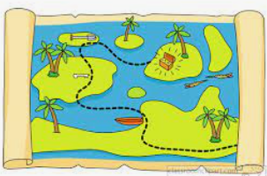  Optional tasks to compliment our topic
Practice your spellings lots of times in and out of order ready for spelling test every Friday. | Keep a weather chart or weather diary for a short period of time.  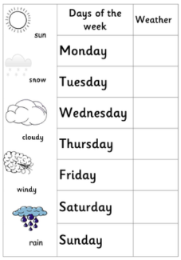 | Read as many traditional tales as you can with a grown up.  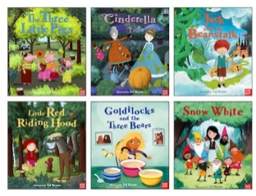  Discuss the characters, setting, morals of the stories, problem/solution in the stories.
Practice the green and red word grids sent home to build your fluency and word recognition.

Your reading book will go home on a Friday and need to be returned on a Tuesday.  Please read this book and ask a grown-up to comment in your yellow reading record book. | Look carefully at your house from the outside. Sketch a picture of it.  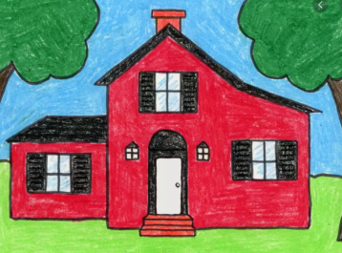  You could even draw a map of the your garden or local area. | Write a book review about a traditional tale.  You could include a brief summary of the story, the main characters, did you enjoy the story.

