A Step back in Time - KS1 Hªo°e[ŸoŒ„ Aªc[t[i[vi[t[¬e¡

P¶i]c[„ ªa[n]d ªc[h]šoÇe ¶™h[ich ªa]c[t[i[vi[t[¬e¡ ¶Ó‹u ¶Ÿou[ld ¶l[i[…e ¶t]‹ ªc]om[p[¯e[·e ¶t[h[i¡ ¶h]a[ló ¶·e[rm, colour the smiley face to show which you completed.
Ió ¶Ó‹u ¶Ÿou[l]d ¶l[i[„e ¶t]‹ ¡[h]are ¶Óou[r ¶h]o°e[ŸoŒ„ p[¯e]a¡e ¶b[ri[n]ü ¶i[t ¶i[n[t]‹ ¡]c[h]šŠl ¶b[þ Thursday 30th March or alternatively email it to
homework daneroyd.com (let the teacher know!)

Weekly tasks | 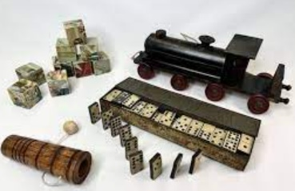  Optional tasks to compliment our topic
Practice your spellings lots of times in and out of order ready for spelling test every Friday. | History  Can you find out what toys your parents, grandparents, great grandparents played with when they were your age? | Art  Can you ceate a 3D picture using the skills learnt in our art lessons?  It could be a picture of a toy.
Practice the green and red word grids sent home to build your fluency and word recognition.

Your reading book will go home on a Friday and need to be returned on a Tuesday.  Please read this book and ask a grown-up to comment in your yellow reading record book. | Science  Can you look around your house and see if you can find things made from different materials?  (wood, glass, plastic, fabric, stone etc) | Year 1  Add and subtract within 20  Can you write number sentences and work them out by counting forwards or backwards?  Year 2  Recall my 2, 5 and 10 times tables.  Can you write our multipcation and division number sentences using these facts?

