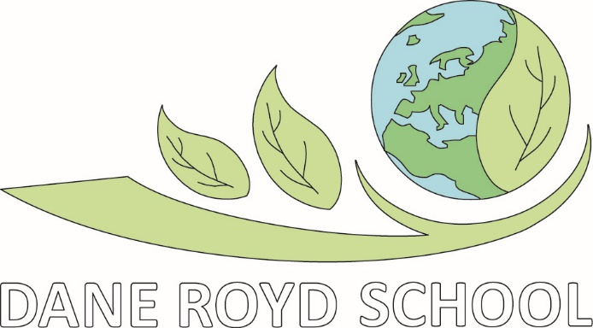
Music Policy

History

STATUTORY DOCUMENT

Review frequency:

Approval by: Standards Committee

Policy Date: September 2023
Review Date: September 2024
Lead Personnel: Bethany McNally
Version: 2
Reviewed 31/1/24

Aims which guide our policies and practice
As a school, we seek to promote shared moral and ethical values to unite both local and global interests which enable children to become global citizens. Our agreed school aims are:
- To create a happy and stimulating learning environment, in which each child will develop to their full potential, thereby achieving high educational standards.
- To develop self-awareness, self-respect and tolerance of others by developing an understanding of the world in which they live.
- To appreciate human achievements and aspirations; develop aesthetic sensitivity and appreciation; physical ability and co-ordination and a concern for the safety of themselves and others.
- To prepare children to live and work with others, enabling them to be responsible and caring members of the community.
- To give children, at the end of their period of primary education, an appetite for acquiring further knowledge, experience and skills, so ensuring they are prepared for the challenges of the next stage in their education.
We ensure that all of our policies and practices are guided by these aims and we seek to ensure that they are at the forefront of all that we do.

Music

- Our Vision

1.1 What is our Intention for Music at Dane Royd?
As musicians, we want our children to be able to be confident, musical and engaged in what we offer at Dane Royd. We believe that children who learn music at any level learn self- discipline, expression through sound, fine motor skills, further develop problem solving skills and learn how to ignite the creative and critical mind.
At Dane Royd we believe that a high-quality music curriculum inspires children to want to become better musicians and well-rounded children. Music lessons improve listening skills, encourages creativity and fosters team work. At Dane Royd we ensure that music is for everyone, that it is fun and that the lessons are educational building blocks. We want to ensure that music isn’t just for primary school, it is for life.

1.2 Attitude and skills
We also seek to encourage children to develop the following skills:

- Confidence
- Self-belief
- Creativity
- Performing
- Composing
- Evaluating
- Listening

- Roles and responsibilities

2.1 The Role of the Music Co-ordinator is:
- Taking the lead in the development, evaluation and amendment of schemes of work as and when necessary
- Acting as a consultant to colleagues on resources, visits, visitors, curriculum changes, classroom teaching and learning ideas
- Monitoring and evaluating pupils’ work, pupils’ views about the subject, displays and teachers’ planning
- Auditing resources and ordering resources when needed
- Keeping up to date with developments in music and disseminating information to the rest of the teaching staff
- Attending relevant in-service training and prompting others about relevant training
- Leading staff meetings where appropriate

2.2. The role of the Senior Leadership team
- The SLT has responsibility to ensure the music policy is implemented throughout the school through work scrutiny, lesson observation and discussion with pupils.
- The SLT also monitors and evaluates the impact of policy development on the quality of learning, reviews the teaching of music in light of new developments and initiatives and deploys staff to ensure that the quality of provision is secure.

2.3 The role of the class teacher
- Implementing the music curriculum according to the policy document
- Ensuring high standards of teaching and learning within the classroom.
- Assessing pupil’s learning to ensure progression in music
- Ensuring music is accessible to all pupils through differentiated activities and appropriate support.

2.4 The role of the pupils
- Engage in music lessons
- Follow the behaviour policy during lessons with staff both internally and externally
- Take part in extra-curricular music activities

2.5 The role of the Governing Body
- Governors have overall responsibility for the quality of music provision in the school.

- Teaching and Learning
3.1 Foundation Stage
We teach music in Nursery and Upper Foundation Stage classes as an integral part of the topic work covered during the year. As part of the Early Years Foundation Stage of the National Curriculum, we relate the musical aspects of the children’s work to the objectives set out in the Early Learning Goals (ELGs). Music contributes to a child’s personal and social development. Counting songs foster a child’s mathematical ability, and songs from different cultures increase a child’s knowledge and understanding of the world. Nursery and Reception classes also have access to the Kapow Music Scheme. They also take part in whole school music appreciation lessons to give them a starting point to their music education learning about the inter related dimensions. Throughout the academic year children will learn songs as part of celebrations and cultural festivals for example Harvest and Christmas. They will also learn songs within the JIGSAW PSHE scheme. The whole school has an artist of the month whose music will be played during assemblies and throughout the month – the aim of the artist is to develop children’s appreciation of a wider range of music. The artists selected reflect diversity of the history of influential musicians. We teach children songs that they can then perform.

3.2 Key Stages 1 and 2
Dane Royd uses the Kapow scheme as the basis for its curriculum planning. This scheme has an integrated, practical, exploratory and child led approach to musical learning. The learning within this scheme is based on:
- Performing
- Composing
- Listening
- History of music
- Inter-related dimensions of music: pulse, pitch, duration, dynamics, tempo, timbre, texture, structure, musical notation
While there are opportunities for children of all abilities to develop their skills and knowledge in each unit, the progression planned into the scheme of work means that the children are increasingly challenged as they move through the school. All musical learning in the scheme is based around the Interrelated Dimensions of Music; pulse, pitch, duration, dynamics, tempo, timbre, texture, structure, musical notation.
Children in Lower Key Stage Two have First Access music lessons with Wakefield Music Service learning the ukulele.
In addition to weekly music lessons each class will have a half-termly lesson to focus on a specific inter-related dimension of music during music appreciation. This will help to show progression through school and develop the children’s understanding of music.
Throughout the academic year children will learn songs as part of celebrations and cultural festivals for example Harvest and Christmas. They will also learn songs within the JIGSAW PSHE scheme. We teach children songs that they can then perform.
As a school we have also gone beyond the statutory requirements by taking aspects of the Model Music Curriculum and embedded them into our music curriculum within school. See appendix C for the Model Music Curriculum.
The whole school has an artist of the month whose music will be played during assemblies and throughout the month – the aim of the artist is to develop children’s appreciation of a wider range of music. The artists selected reflect diversity of the history of influential musicians.
3.3 Teaching Sequence
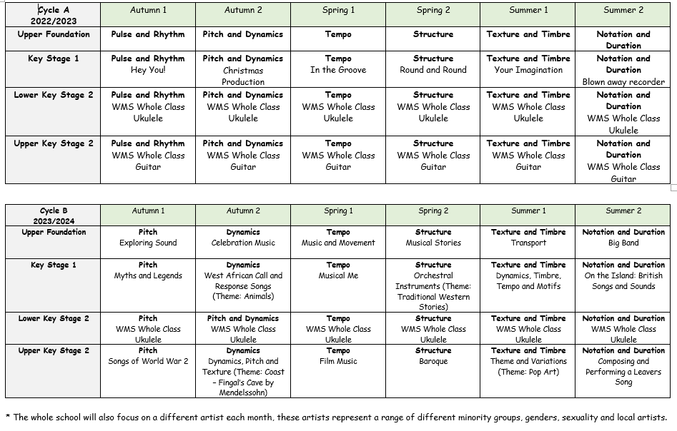

3.4 Additional Music Teaching
As well as national curriculum music lessons, at Dane Royd, we have a range of peripatetic group and individual lessons. These include brass, woodwind, strings and guitar. These are available for children in Year 2 upwards. For children in UFS and KS1 they have the opportunity to learn to play in a band through the Rock Steady Programme.
Outside of the class music lessons the music co-ordinator holds weekly singing assemblies for the whole school.
Children from Year 1 through to Year 6 are invited to be part of the school choir. They rehearse weekly, during the school day, to prepare for concerts, competitions and events within the local community. Highlights for the children are being able to take part in the Young Voices Concert in Sheffield Arena as well as competing against other school choirs in local music festivals.
For children in Key Stage Two they can also be part of ocarina club. A weekly lunchtime club that allows children to learn a new instrument along with their peers.

3.5 Musical Events
Every Christmas each key stage perform a Christmas production for parents, we also perform a Christmas concert by the choir and instrumentalists. The choir are also invited to sing in the local community including turning on Christmas lights and at a care home. The whole school also take part in a carol singing service at a local church.
Throughout the year children have opportunities to perform both in school concerts as well as within the community. A highlight of these for the choir is Young Voices and local competitions.
At Dane Royd we also try to get as many professional musicians to come into school so the children get to experience listening to live performances.
- Assessment:
4.1 Recording of Music
Within music lessons teachers and TA’s will record the children’s work using ipads to show the progress children make, focussing on the process they go through, not just the final performance. This will help children to evaluate their work throughout the topic.
As a school we will also make a book each half term showing the progression throughout school. Each book will have a different IRD focus. In it will show photographs of the children and photocopies of their work. It will also have comments from pupils showing what they have learnt and evaluations of their work.

4.2 Assessment
Each half term teachers will assess the children against the IRD focus of that half term linking to the national curriculum objectives. Children’s progress is then monitored through observations and discussions with the Wakefield Music Service teachers.

4.3 Marking
Marking will take place through verbal feedback throughout lessons. Pupils can then act immediately on this feedback to improve their work. Older children will also be able to help evaluate their peers work and comment on what is good about it and give advice as to how they think it could be improved.

4.4 Monitoring and evaluation
Music will be monitored throughout the school by the Music Co-ordinator who will be responsible for gathering samples of curriculum work.
The Music Co-ordinator will also monitor schemes of work to ensure that the Programmes of Study are being effectively taught and match the needs and abilities of the pupils.
Lessons ideally will also be monitored to help promote quality of learning and standards of achievement in Music.

- Aspects
5.1 Equal Opportunities
- We plan our classroom activities to challenge and involve all pupils appropriately, according to age and capability, ethnic diversity, gender and language background
- We are aware of different learning styles and the need to allow pupils the opportunity to be able to work in their preferred learning styles.

5.2 Differentiation
At our school we teach music to all children, whatever their ability. Music forms part of the school curriculum policy to provide a broad and balanced education to all children. Through our music teaching we provide learning opportunities that enable all pupils to make progress. We do this by setting suitable learning objectives and responding to each child’s different needs. Assessment against the National Curriculum allows us to consider each child’s attainment and progress against expected age related expectations. We use a range of strategies to support pupils.
A few of these, particularly relevant to Music are:
- Extra support for children who need it within both lessons and extra-curricular clubs
- Differentiated questions based on children’s ability
- Range of ways to read music from colour co-ordinated, note names and picture support
- Support in remembering lyrics using different strategies specific to children’s needs
5.3 More able students
Children are challenged throughout the school year and those who are more able are given the opportunity to progress within music lessons as well as in extra-curricular activities. At Dane Royd children get a chance to learn instruments through peripatetic lessons. The more able children are advised to have 1:1 lessons to help them progress even further.

5.4 SEND students
Children throughout school have extra support within music lessons and during extra-curricular activities. No child is left out of music activities due to their needs.

5.5 Health and safety
Any musical visits must follow the schools Health and Safety policy and risk assessment procedures. Teachers are required to complete a full risk assessment using the Evolve Website. These must be then passed to the Music Co-Ordinator, the Educational Visit Officer and the Head-teacher, who will present the risk assessments to Governors, who will then sign the visit off.

- Organisation
6.1 Homework/parent partnership:
Music homework may be set by teachers to either prepare for a lesson or as part of consolidation work from a topic lesson. Objectives are usually open-ended, allowing children to complete the task in their own way. Many of the Music homework tasks tend to be creative and children are encouraged to use a range of mediums and resources to present their homework.

6.2 Resources:
The following resources are available to aid the teaching of music at Dane Royd:
- Kapow music scheme – all teachers have individual logins
- sound system, laptop and projector in the hall
- a selection of un-tuned percussion instruments
- tuned instruments – glockenspiels and recorders
- ukuleles on loan from WMS
- school log in for Sing Up
- range of music books of songs for assemblies and lessons
Concluding notes

Monitoring and review:
This policy will be reviewed in September 2024; however a review will commence before this proposed date if any national changes occur.

Other documents and appendices:
Appendix A – The National Curriculum Programme of Study for Music
Appendix B – Progression of the Interrelated Dimensions of Music
Appendix C – Model Music Curriculum

Appendix A
Music programmes of study: key stages 1 and 2

National curriculum in England

Purpose of study
Music is a universal language that embodies one of the highest forms of creativity. A high quality music education should engage and inspire pupils to develop a love of music and their talent as musicians, and so increase their self-confidence, creativity and sense of achievement. As pupils progress, they should develop a critical engagement with music, allowing them to compose, and to listen with discrimination to the best in the musical canon.

Aims
The national curriculum for music aims to ensure that all pupils:
- perform, listen to, review and evaluate music across a range of historical periods, genres, styles and traditions, including the works of the great composers and musicians
- learn to sing and to use their voices, to create and compose music on their own and with others, have the opportunity to learn a musical instrument, use technology appropriately and have the opportunity to progress to the next level of musical excellence
- understand and explore how music is created, produced and communicated, including through the inter-related dimensions: pitch, duration, dynamics, tempo, timbre, texture, structure and appropriate musical notations.
Attainment targets
By the end of each key stage, pupils are expected to know, apply and understand the matters, skills and processes specified in the relevant programme of study.

Subject content

Key stage 1
Pupils should be taught to:
- use their voices expressively and creatively by singing songs and speaking chants and rhymes
- play tuned and untuned instruments musically
- listen with concentration and understanding to a range of high-quality live and recorded music
- experiment with, create, select and combine sounds using the inter-related dimensions of music.
Key stage 2
Pupils should be taught to sing and play musically with increasing confidence and control. They should develop an understanding of musical composition, organising and manipulating ideas within musical structures and reproducing sounds from aural memory.
Pupils should be taught to:
- play and perform in solo and ensemble contexts, using their voices and playing musical instruments with increasing accuracy, fluency, control and expression
- improvise and compose music for a range of purposes using the inter-related dimensions of music
- listen with attention to detail and recall sounds with increasing aural memory
- use and understand staff and other musical notations
- appreciate and understand a wide range of high-quality live and recorded music drawn from different traditions and from great composers and musicians
- develop an understanding of the music of music.

Appendix B
Progression of the Interrelated Dimensions of Music

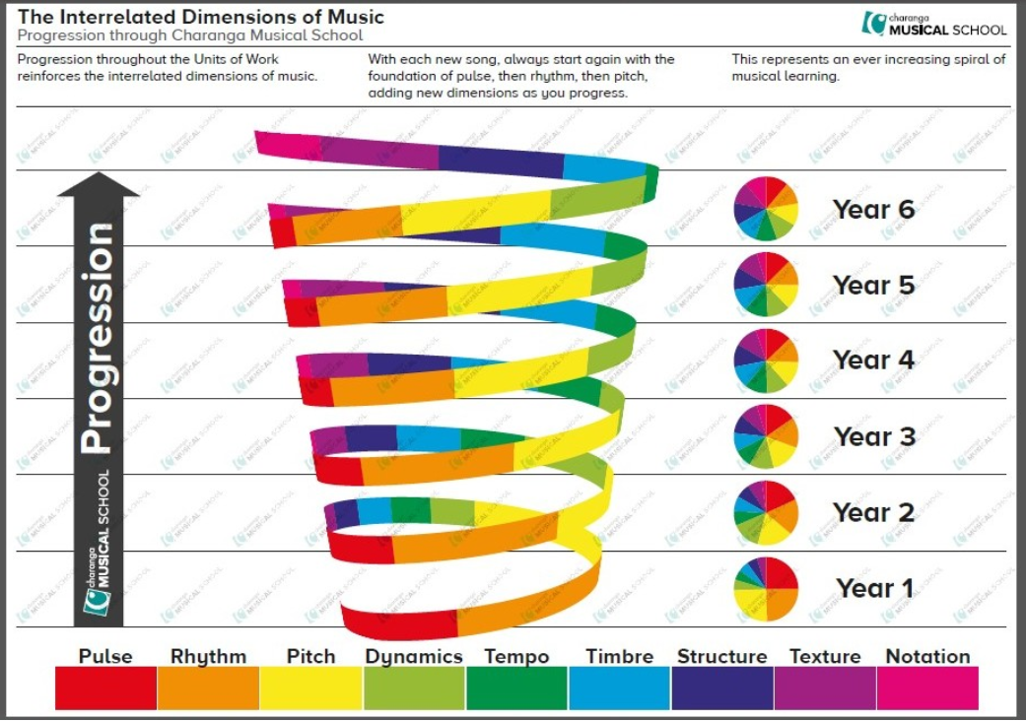

Appendix C
Model Music Curriculum
https://assets.publishing.service.gov.uk/government/uploads/system/uploads/attachment_data/file/974366/Model_Music_Curriculum_Full.pdf

