Computing
Computing Policy

STATUTORY DOCUMENT
Review frequency:

Approval by: Standards Committee

Policy Date: January 2019
Review Date: January 2022
Lead Personnel: Beth Hemingway
Version: 2

Aims which guide our policies and practice
As a school, we seek to promote shared moral and ethical values to unite both local and global interests which enable children to become global citizens. Our agreed school aims are:
- To create a happy and stimulating learning environment, in which each child will develop to their full potential, thereby achieving high educational standards.
- To develop self-awareness, self-respect and tolerance of others by developing an understanding of the world in which they live.
- To appreciate human achievements and aspirations; develop aesthetic sensitivity and appreciation; physical ability and co-ordination and a concern for the safety of themselves and others.
- To prepare children to live and work with others, enabling them to be responsible and caring members of the community.
- To give children, at the end of their period of primary education, an appetite for acquiring further knowledge, experience and skills, so ensuring they are prepared for the challenges of the next stage in their education.
We ensure that all of our policies and practices are guided by these aims and we seek to ensure that they are at the forefront of all that we do.

Computing

Intent

At Dane Royd, we want our pupils to acquire a wide range of computing skills and strategies to enable them to become skilled informational technologists, computer scientists and digital literacy experts. We aim to allow children to investigate and understand a wide range of computing skills that will prepare them for wider, later life. We want children to be hooked in to a variety of projects which will develop not only their skillset, but their imagination, and leave them with a love for technology. We also want children to understand the wider impact and purpose of a wide range of technologies and how computers can impact the world we live in by exploring the many everyday purposes we use technology for. Our main aim is to embed in pupils an engagement and enthusiasm for computer science and its links with the wider world and other areas.

Attitude and skills
We also seek to encourage children to develop the following skills:
- Critical and logical thinking
- Computational thinking
- Become digitally literate
- Creativity
- Logical reasoning

Intent

Procedures and practice
2. Roles and responsibilities

The Role of the Computing Co-ordinator is:
- Taking the lead in the development, evaluation and amendment of schemes of work as and when necessary
- Acting as a consultant to colleagues on resources, visits, visitors, curriculum changes, classroom teaching and learning ideas
- Monitoring and evaluating pupils’ work, pupils’ views about the subject, displays and teachers’ planning
- Auditing resources and ordering resources when needed
- Keeping up to date with developments in Computing and disseminating information to the rest of the teaching staff
- Attending relevant in-service training and prompting others about relevant training
- Leading staff meetings where appropriate

3. Aspects

Equal Opportunities
The school is committed to promoting equal opportunities for the distribution and access to resources ensuring every child, regardless of race, gender or class, has the opportunity to make progress within the computing curriculum. The school is aware that not every child has the same access to hardware or software at home and therefore sets no requirements that homework is completed by this means. It also makes no assumptions that children have prior knowledge of the equipment available in school.

Differentiation
At our school we teach Computing to all children, whatever their ability. Computing forms part of the school curriculum policy to provide a broad and balanced education to all children. Through our Computing teaching we provide learning opportunities that enable all pupils to make progress. We do this by setting suitable learning objectives and tasks and by responding to each child’s different needs. Assessment against the National Curriculum allows us to consider each child’s attainment and progress against expected age related expectations. We use a range of strategies to support pupils. A few of these, particularly relevant to Computing are:

- The use of appropriate vocabulary at varying levels of difficulty during lessons
- The use of different apps according to levels of difficulty
- Different levels of questions for pupils

For our gifted and talented pupils we will expect:

- Teachers to provide teaching and learning experiences that encourage pupils to think creatively, explore and develop ideas, and try different approaches. Pupils should be encouraged to set their own questions, offer ideas, suggest solutions or explanations, and reflect on what they have heard, seen or done in order to clarify their thoughts.
- Greater independence in working, e.g. a pupil to be able to decode, critically and logically think, and problem solve independently.
- Provide opportunities within Computing for pupils to develop their skills in other areas, such as intrapersonal skills (for example, opportunities to use initiative), and interpersonal skills (for example, leadership and group membership). These opportunities also relate to the key skills of working with others and improving own learning and performance.
- Provide cross-curricular opportunities such as links with writing, mathematics and science.
Health and safety:
All equipment is checked annually under the ‘Electricity at Works Regulation 1989’. Pupils use laptops and therefore have no access to the wires; these are stored within the trolley and cannot be removed without adult supervision. Pupils are aware of the rules associated with using the hardware and the potential dangers.
Planning:
Year 1 Cycle
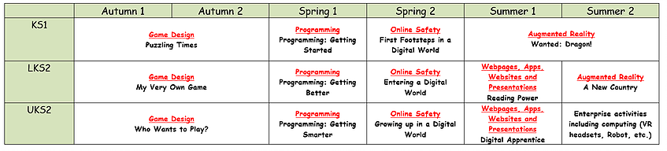
Year 2 Cycle
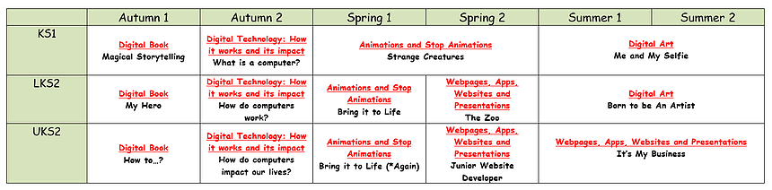
Teaching:
Foundation Stage
- The Foundation Stage has a curriculum based on exploration and play based experiences, through both indoor and outdoor provision. Foundation Stage should include learning environments that give access to a range of COMPUTING scenarios they would encounter in real life. Children in Foundation Stage have access to a range of hardware including: Interactive white board (IWB), iPads and cameras. There is appropriate software installed on all hardware to give opportunity for development across a variety of subjects. There is also a specific early years scheme of work on the Mr Andrew’s Online curriculum which is called ‘Once App On a Time’, which focuses on different popular fairy tales and work on the iPads. Each project within this scheme also covers other early learning goals and this is clear and evident through planning.

Key Stage 1

Pupils in Key Stage 1 should understand what algorithms are, how they are implemented on programmes, and that programmes execute by following instructions. They should be able to write, test and debug simple programmes, using logical reasoning to predComputing the behaviour of such programmes. Pupils should organise, store, retrieve and manipulate data in a range of digital formats. They should be taught how to use COMPUTING safely both in and out of school, and how to be safe and respectful online. They should also be taught and understand how to keep personal information private, and to be able to identify where to go for help and support if they have concerns about online interactions or programmes. The school is currently following the ‘Mr Andrew’s Online Creative Computing Curriculum’. This contains detailed projects, including detailed and thorough planning. A long-term, rolling curriculum plan has been put into place, with projects assigned to Key Stage topics. Staff are encouraged to follow this plan and each project as it is set out, until they become comfortable with meeting the requirements of the new curriculum in detail so that they can adapt projects to different topics and outcomes. The COMPUTING and Computing Co-ordinator has ensured that all current hardware can achieve the aims of this scheme of work and that any software has been installed across the necessary hardware.

Key Stage 2

- Pupils in Key Stage 2 should design programmes that achieve a set goal. They should work with variables to change input and outputs in order to solve problems, using logical reasoning to write and explain simple algorithms whilst also detecting and correcting any errors that they might find. Pupils should have an understanding of networks, looking particularly at the internet and how it provides opportunities for communication and collaboration. Explore how internet search engines find and store data, use search engines effectively by discerning and evaluating digital content and respecting individuals’ intellectual property. They should also use a variety of software to collect, analyse, evaluate and present data and information. Pupils in this Key Stage should also understand how to use technology in a safe, respectful and responsible manner, recognising unacceptable behaviour and identifying ways to report concerns. This contains detailed projects, including detailed and thorough planning. A long-term, rolling curriculum plan has been put into place, with projects assigned to Key Stage topics. Staff are encouraged to follow this plan and each project as it is set out, until they become comfortable with meeting the requirements of the new curriculum in detail so that they can adapt projects to different topics and outcomes. The COMPUTING and Computing Co-ordinator has ensured that all current hardware can achieve the aims of this scheme of work and that any software has been installed across the necessary hardware.

Organisation:
Homework/parent partnership:
The school website is updated frequently. The site has been specifically designed with ease of use in mind. Parents and pupils can use the website to view policies and long term plans. Key communications are posted on the web page for parents to view. A school Twitter account, as well as individual class Twitter accounts, is used to provide parent with updates about the school and celebrate achievements.

Resources:
The school is well equipped with resources appropriate for the planned projects. Resources in school include:
- Interactive White Boards
- Interactive voting systems
- Laptops (some with CD and DVD drives)
- Projectors
- Digital cameras
- Digital video cameras
- Tape recorders
- Laptops
- iPads
Assessment:
Recording of Computing
Pupils are encouraged to record their work using a variety of methods and therefore communicate their findings to others. Children when using the iPads save work to that specific iPad and the class teacher then ‘air drops’ or transfers a selection of children’s work on to their class iPads. For some projects there are also quizzes, for which, class teachers again keep a selection of (a representative sample.). There are also writing opportunities and comprehension opportunities which can be recorded in the appropriate exercise books.

Assessment
Class teachers are required to make ongoing formative assessments of pupils’ abilities within the computing curriculum. Summative assessment are to be undertaken by class teachers using the excel spreadsheet assessment tools, assessing whether children in their class are working towards, at or above their age related expectations, based on the National Curriculum objectives they have been taught.

Marking
Feedback to pupils should be provided verbally on their attainment against the objectives of Computing. Pupils are encouraged to improve their own learning performance and evaluate their work based on the learning objective and success criteria.

Monitoring and evaluation:
The quality of computing and COMPUTING work throughout school will be monitored by the subject co-ordinator through lesson observations and evidence of work undertaken in class including photographic evidence. The subject leader is responsible for maintaining the subject leaders file. The subject leader is responsible for reporting to the Governing Body through presentations.

Concluding notes
Monitoring and review:
This policy will be reviewed in January 2022; however a review will commence before this proposed date if any national changes occur.

