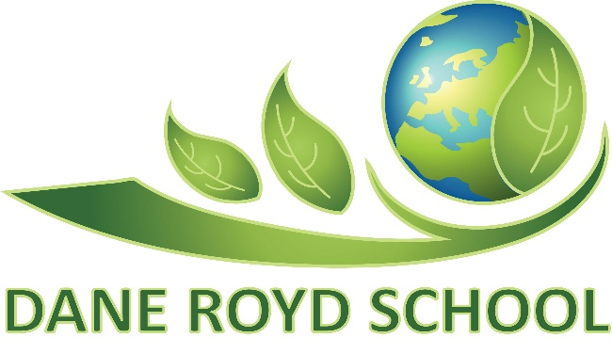
EYFS Policy
Review Frequency: Annually
Approval By: Standards Committee of Governing Body

Policy Date: September 2022
Review Date: September 2023
Lead Personnel: Carey Ward
Version: 1

History

Aims which guide our policies and practice
As a school, we seek to promote shared moral and ethical values to unite both local and global interests which enable children to become global citizens. Our agreed school aims are:
- To create a happy and stimulating learning environment, in which each child will develop to their full potential, thereby achieving high educational standards.
- To develop self-awareness, self-respect and tolerance of others by developing an understanding of the world in which they live.
- To appreciate human achievements and aspirations; develop aesthetic sensitivity and appreciation; physical ability and co-ordination and a concern for the safety of themselves and others.
- To prepare children to live and work with others, enabling them to be responsible and caring members of the community.
- To give children, at the end of their period of primary education, an appetite for acquiring further knowledge, experience and skills, so ensuring they are prepared for the challenges of the next stage in their education.
We ensure that all of our policies and practices are guided by these aims and we seek to ensure that they are at the forefront of all that we do.
Contents
1. Introduction & Aims
2. Legislation
3. Structure of the EYFS
4. Curriculum
5. Observatioon & Assessment
6. Working with parents
7. Safeguarding and welfare procedures
8. Inclusion
9. Monitoring arrangements

Introduction & Aims

“Science tells us that a child’s experiences from conception through their first five years will go on to shape their next 50. It tells us that the kind of children we raise today, will reflect the kind of world we will live in tomorrow.”

State of the Nation: Understanding Public Attitudes to the Early Years, November 2020.

Every child deserves the best possible start in life and the support that enables them to fulfil their potential.

Here at Dane Royd, we aim to provide the highest quality of care and education for all our children.

We do this by ensuring:

quality and consistency so that every child makes good progress and no child gets left behind.

a secure foundation through planning for the learning and development of each individual child, and assessing and reviewing what they have learned regularly.

partnership working between practitioners and with parents and/or carers.

equality of opportunity and anti-discriminatory practice, ensuring that every child is included and supported.

2. Legislation

This policy is based on the legal requirements set out in the Statutory Framework for the Early Years Foundation Stage (EYFS).

The guiding principles that shape our practice are:

• every child is a unique child, who is constantly learning and can be resilient, capable, confident and self-assured.

• children learn to be strong and independent through positive relationships.

• children learn and develop well in enabling environments with teaching and support from adults, who respond to their individual interests and needs and help them to build their learning over time.

• the importance of learning and development and the understanding that children develop and learn at different rates.

3. Structure of the EYFS

Our EYFS setting is structured across 2 year groups; Nursery or Lower Foundation Stage (LFS) and Reception or Upper Foundation Stage (UFS). A maximum of 52 part-time children can be admitted to our Nursery and 45 full-time children to our Reception.
Nursery admissions follow the model Early Years Part-time Admissions Policy set by Wakefield Council. We also offer Wraparound care as part of our Extended Schools Provision. Our Charging and Remissions Policy and Extended Schools Pricing Policy contain full details of current rates. Please note that these only apply to families NOT eligible for 15 hours free entitlement.
Reception admissions are allocated based on Wakefield Council’s Admissions Policy.

4. Curriculum

We have designed a broad and balanced progressive Early Years curriculum aligned to Development Matters (non-statutory guidance) alongside the new statutory framework for EYFS that applies from September 2021.

All seven areas of learning and development are important and inter-connected.

The prime areas of development are particularly crucial for igniting children’s curiosity and enthusiasm for learning, and for building their capacity to learn, form relationships and thrive.

Prime Areas of Development

• communication and language

• physical development

• personal, social and emotional development

Children are also supported through the specific areas, through which the prime areas are strengthened and applied.

Specific Area of Development

• literacy

• mathematics

• understanding the world

• expressive arts and design

4.1 Planning

Staff plan activities for children that enable them to develop and learn effectively.
They take in to account individual needs, interests, and stages of development for every child in their care, and use this information to plan challenging and enjoyable experiences. Where a child may have a special educational need or disability, staff consider whether specialist support is required, linking with relevant services from other agencies, where appropriate.

In planning and guiding children’s activities and experiences, staff reflect on the different ways that children learn and include these in their practice.

The characteristics of effective teaching and learning are:

playing and exploring - children investigate and experience things, and ‘have a go’.

active learning - children concentrate and keep on trying if they encounter difficulties.

creating and thinking critically - children have and develop their own ideas, make links between ideas and develop strategies for doing things.

4.2 Teaching

Each area of learning and development is implemented through planned, purposeful play experiences alongside a mixture of adult-led and child-initiated activities. Staff respond to each child’s emerging needs and interests, guiding their development through warm, positive interactions.

As children grow older, and as their development allows, the balance gradually shifts towards more adult-led activities that help children prepare for more formal learning in Key Stage 1.

5. Observation & Assessment

Ongoing observation and assessment are an integral part of the learning and development process. Staff observe pupils to identify their level of achievement, interests and learning styles. They also take in to account observations shared by parents and/or carers. These are then collated into a personalised learning journey and used to shape future planning and provision.

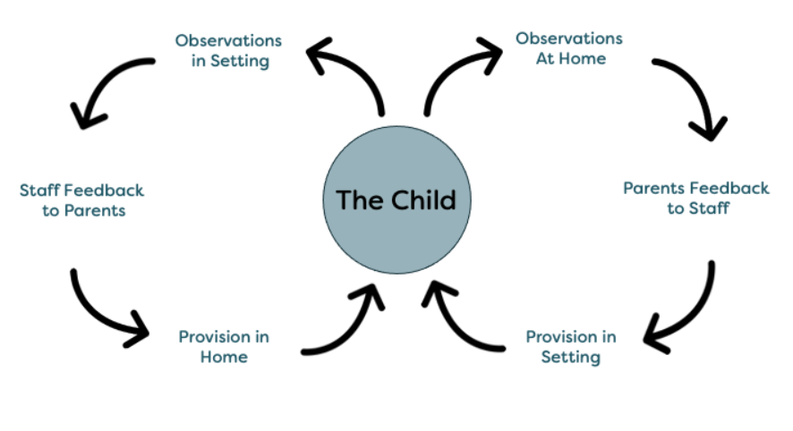

5.1 Start of Reception

Within the first 6 weeks that a child enters Reception, staff administer the Reception Baseline Assessment (RBA). This provides a starting point of where pupils are when they arrive in school and enables the Government to measure progress at the end of primary school. School will provide parents and/or carers with a narrative description of how each child performed in the assessment.

5.2 End of EYFS

In a child’s final term of Reception, staff complete the Early Years Foundation Stage Profile (EYFSP). Pupils are assessed against the 17 early learning goals, indicating whether they are:
- Meeting expected levels of development
- Not yet reaching expected levels (‘emerging’)
The profile is moderated internally to ensure consistent assessment judgements. The results are shared with parents and/or carers and data is also submitted to the local authority.

The RBA and EYFSP are enforced by the same legislation, however they are distinct and serve different purposes. There will be no interaction between the two assessments in practice.

6. Working with parents

We recognise that children learn and develop well when there is a strong partnership between staff and parents and/or carers. Parents and/or carers are kept up to date with their child’s progress and development throughout the year in various ways.

Staff provide Curriculum Booklets, Knowledge Organisers and (optional) Homework for each half-termly topic, highlighting how parents and/or carers can support their child at home. They are also invited into school at regular intervals throughout the academic year for Consultation and Curriculum Events and ‘Steps to Success’ and ‘End of Year’ reports are shared.

Each child is assigned a key person. Their role is to help ensure that every child’s care is tailored to meet their individual needs, to help the child become familiar with the setting, offer a settled relationship for the child and build a relationship with their parents.

7. Safeguarding and welfare procedures

The safeguarding and welfare of our children is paramount. We have robust policies and procedures in place to ensure their safety:

Safeguarding Policy
Mental Health and Well-being Policy
Health & Safety Policy
Intimate Care Policy

8. Inclusion

We value all of our children as individuals, irrespective of their ethnicity, culture, home language, background, ability and gender. We plan a curriculum that meets the needs of the individual child and support them to achieve their potential.

We strongly believe that early identification and intervention is crucial and work extremely close with parents and/or carers and a range of outside agencies in order to ensure appropriate provision is in place at the earliest opportunity.

Mr Davison is our SENCO and designated Inclusion Leader in school who supports us with any additional needs a child may have.

9. Monitoring arrangements

This policy will be reviewed annually as standard however should any major changes occur within the education sector an impromptu review may commence outside of the proposed time frame.

