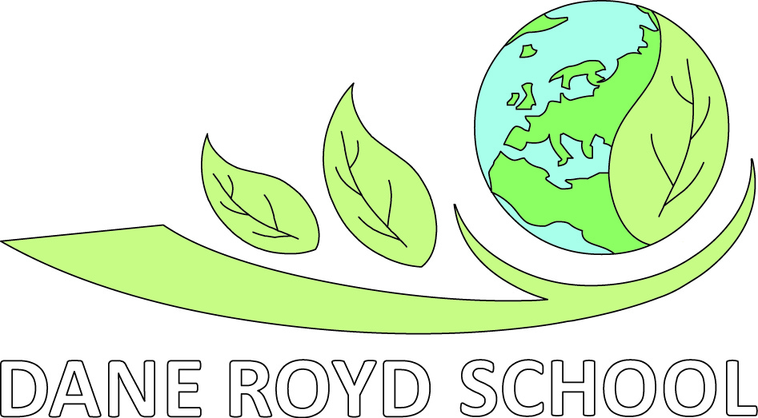
Uniform Policy
STATUTORY DOCUMENT
Review frequency: Every three years

Approval by: Standards Committee

Legislation:
Policy Date: August 2019
Review Date: August 2022
Lead Personnel: Headteacher
Version: 1
Revision Date: N/A

Aims which guide our policies and practice
As a school, we seek to promote shared moral and ethical values to unite both local and global interests which enable children to become global citizens. Our agreed school aims are:

- To create a happy and stimulating learning environment, in which each child will develop to their full potential, thereby achieving high educational standards.
- To develop self-awareness, self-respect and tolerance of others by developing an understanding of the world in which they live.
- To appreciate human achievements and aspirations; develop aesthetic sensitivity and appreciation; physical ability and co-ordination and a concern for the safety of themselves and others.
- To prepare children to live and work with others, enabling them to be responsible and caring members of the community.
- To give children, at the end of their period of primary education, an appetite for acquiring further knowledge, experience and skills, so ensuring they are prepared for the challenges of the next stage in their education.
We ensure that all of our policies and practices are guided by these aims and we seek to ensure that they are at the forefront of all that we do.
Dane Royd Primary School Policy for School Uniform
It is our school policy that all children wear school uniform when attending school, or when participating in a school-organised event outside normal school hours.

Our policy on school uniform is based on the notion that school uniform:
· promotes a sense of pride in the school;
· engenders a sense of community and belonging towards the school;
· is practical and smart;
· identifies the children with the school;
· prevents children from coming to school in fashion clothes that could be inappropriate;
· makes children feel equal to their peers in terms of appearance;
· is regarded as suitable wear for school and good value for money by most parents;
· is designed with health and safety in mind

Introduction.
The school policy for School Uniform was developed and agreed by a working committee of governors including staff, parents and school council.
Aims
Through this policy we aim to:
Ensure that within our school we wish to promote an atmosphere which encourages effort, enjoyment and a celebration of the achievements of all our pupils. The schools concern for these high standards is also reflected in the pride we take in our school uniform and feeling of belonging it creates.
The Governing Body at Dane Royd School will respect variations to our school uniform if they are directly related to established religious or cultural traditions.
However, any variation will be dealt with on an individual basis and judgements will remain at the discretion of the Head Teacher and the Governing Body.

Uniform
In order to maintain a strong sense of identity and belonging within our school, we require all pupils to wear school uniform which consists of;
• Bottle green sweatshirt, jumper or cardigan (With or without the school logo on )
• White shirt or polo shirt (With or without the school logo on )
• Grey trousers
• Grey shorts or culottes
• Grey skirt or pinafore
• Black, flat sensible, safe, shoes

Summer Options
• Grey shorts
• Gingham dresses – green
• Any cap to protect from the sun

PE Kit
• Plain white T-shirt
• Plain Black Shorts
• Trainers for outdoor games
• A plain black tracksuit may be worn for outdoor games in winter.

Jewellery
• It is encouraged that pupils do not wear jewellery to school, especially as individuals become very upset if a treasured piece of jewellery goes missing.
• Should a pupil have pierced ears, plain studs should only be worn and in order to comply with health and safety regulations, must be covered with a plaster during all PE activities.
Please note that the school will be unable to take any responsibility for any jewellery that is lost.
Watches
• Watches may be worn to school. However, they must be before any PE lessons.
Please note that the school will be unable to take any responsibility for any watches that are lost.
Make Up
• No make up or nail varnish should be worn on nails or toes.
Equipment
• Mobile phones should not be brought into school without the permission of the Headteacher. Mobile phones should be handed into the office at the start of the school day and collected at the end of the school day.
• No medicine should ever be brought to school by a child ~ with the exception of
inhalers. Any other medication should be given in to the school office
• No money should be brought to school unless for a specific permissible purpose
• Bags to carry equipment and belongings in should be of a reasonable size as
space in the cloakrooms is limited.
All the items above a readily available from the high street, on line or from a local supplier.
Logoed items are available from The Uniform Centre, Wakefield or from Tesco online.
Our uniform has been kept simple to avoid unnecessary expense. We expect all pupils to follow the dress code as written above.
Hair
Long hair should be tied back during Physical Education lessons for safety.
Pupils can tie their hair back with a hair band. Hair accessories should be discreet and reflect school uniform colours. Children will be asked to removed hair accessories if they are considered a fashion item over a practical accessory. Hair bands should be plain and not raised.
Role of the Head teacher and Governing Body
• The Head teacher to ensure that pupils comply with the uniform policy agreed by the Governing Body.
• The Headteacher has a duty to enforce the school uniform throughout the school community, as part of the duty within maintenance of day to day discipline in the school.
• The Governing Body should be receptive to any reasonable complaint from parents or carers, concerning uniform handling it respectfully, considering fully the issues they raise. Governors should aim to work with parents to arrive at a mutually acceptable outcome.
• The school will follow the DfE guidelines and not consider exclusion from the school where a pupil fails to comply with the school’s rules on uniform.
Role of the Parents/Guardians
• To ensure that their child / children adhere to the school’s uniform policy.
• Ensure that they come to school in uniform everyday unless there are special circumstances such as Christmas parties or charity fun rising.
• Parents and carers should raise any complaints about the school uniform by following the schools complaints procedure.
Racial Equality & Equal Opportunities
All children have equal access to wearing school uniform regardless of their culture, race, religion, gender, disability or ability. We ensure that the set uniform respects other policies such as Race relations, sex discrimination and allows for individual sets of circumstances of all groups and individuals. Dane Royd School is committed to creating a positive climate that will enable everyone to work free from racial intimidation and harassment and to achieve their full potential.
Non-Compliance with the School Uniform Policy
The Headteacher may discipline a pupil for breach of the Uniform/Appearance Policy.
Parents will be contacted where breaches of the Uniform/Appearance Policy are ‘persistent and defiant’. The Headteacher, or another member of staff with delegated authority, may ask a parent to remedy a breach of the school’s rules on uniform or appearance.

